Chris click mouse controlev control s:" 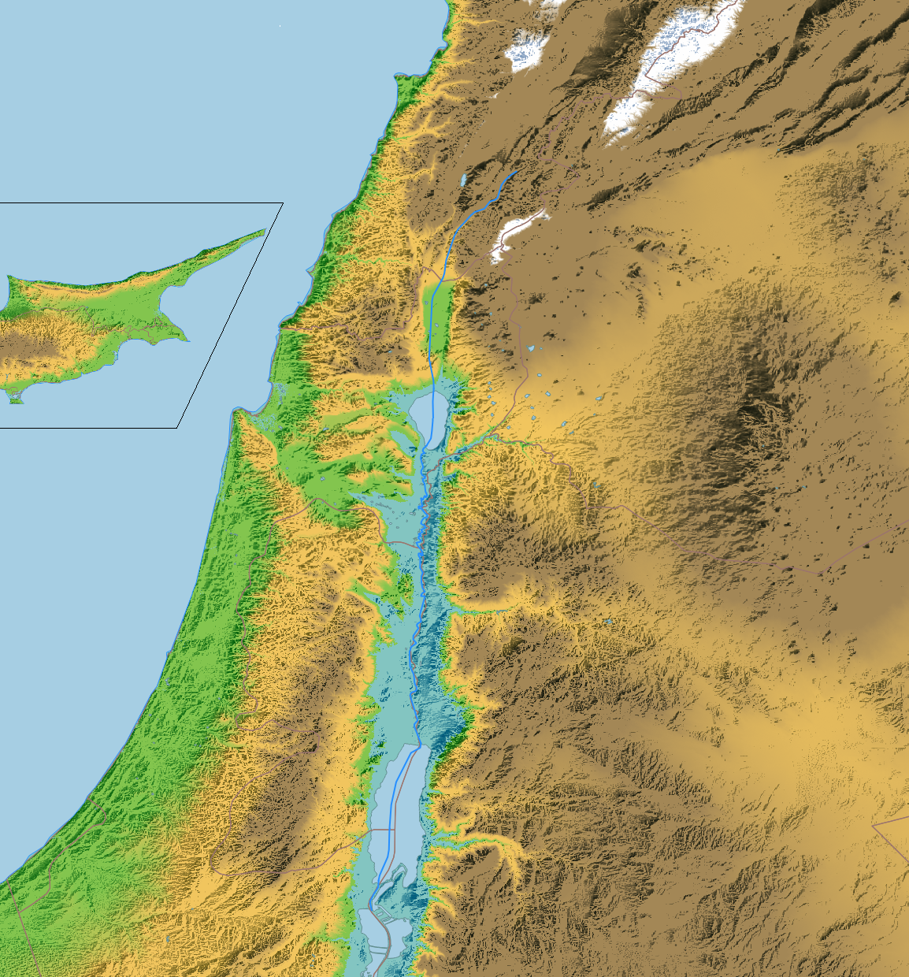

Byblos

Berytus

Apheca

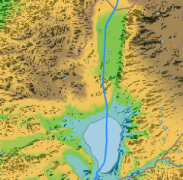

Dalmanutha

Hippos

Tiberias

(A)Dam(n)a(h)

Cydessa**8**

Giskala

Arbela

Taricheah

Jetebatha

Magdala

Gabara

Gennabris

Bethanat

Hanathon

Kinnereth

Capharnaum

Bethsaida

Bethsaida-

Julias

Little Corozain

Gergesa

Sea of Galilee

Lake Tiberias

Holyland, 30 a.d.

By David Rudmin

Compiled from distances in Bl. Anne Catherine Emmerich’s 4 volumes of visions in her *Life of Christ*; with assistance from Claudius Ptolemy, the Peutinger map, & modern Google Earth placenames.

2023, AncientMiddleEast.com

Download the .KMZ file, for higher detail & site-by-site analysis. Please support us.



Alternate Names:

1. Goshen = Tell Ihoudieh

2. Succoth = Ain Sokhna

3. Etham = Matarma

5. Marrah = Magna

6. Elim=“70”=Hippos-come

9. Dophkah = Raphaca

Dophkah = Aqaba?

10. Alush = Ailous

11. Rephidim =

"The Rock at Horeb," =

"Massah & Meribah."

◾ Tabera = Taba Sabkha

13. Kibroth = C-/Gypsaria ?

14. Hazeroth = Hawarath =

Hauarra = Awara =

Al-Quwayrah?

15. Rith(a)mah = Nitzana

16. Rimmon Perez =

Mitzpah Ramon

◾Hormah=Daroma=Deiran

17. Libnah = “White” =

Hakanyon Halavan

18. (Ar-)Riss(h)ah = Lysa

19. Kehelathah = Cletharro

= Khresha

20. Mt. Shapher = Shqira

21. (C)Harada(t)h = Qir =

Qer Harreseth = Kerak

22. Makheloth = Machaerus

= Moca = Al-Mughayer

23. Tahatha = Tafilah

24. Terah = Petra

25. Mathecca=Makna/Maina

26. Selmona = Hashmonah =

Hashemeyeh

Selmona = Zalmonah

27. Moseroth = Al-Mazar

28. Bene = Banaia

Jaakan=Jachza=Shuqayq

29. Hor-Haggidgad = Gud-

godah = Ghor Al-Haditha

30. Jotbatha = "Pleasant" =

At-Tayyibah

31. Abronah = Ebroneh =

"Passage" = Fatha = Fifa

32. (G)Esion Geber = Idan ?

33. Kades(h(a))=Al-Qadisiya

Also Kadesh(a)) Barnea ?

35. (See 26.)

36. Punon=Phaino=Feynan

37.Oboth = Oboda = Eboda

Oboth = Rehoboth

38. Iye = Iyyon = Aij

40.Almon = Amman

41.Abarim = Bethennabris

42.Abel-shittim = Abila

Leontes River

Sidon

Rechob

Cana

Baal-Hermon?

Damascus

Salamis

Citium

Chytrus

Lapithus

Cerinia

Mallep

Leppe

Ornithopolis

Sarepta

Mt. Hermon

Zedad

Lesem/Lais

Hamath Dor?

Dan

Caesarea-Philippi/Paneas

Lake Merom/Semi-chontis

Berotha

Tyre

Sogane?

Lake Phiala

Gess(h)ur?

Mediterranean Sea

Asach?

Cariathaim

Cydessa

Thisbe

Argob

Great Corozain

Nobe/Nobah?

Hazor

Adama

Naasson

Hucuca

Abram/Ebron

Gerasa

Regaba

Elcese

Lecum?

Seleucia

**Cyprus Island**

Galgal

Bethan

Nejel?

Misael

Saphet

Sermon on the Mount

Ptolemais/Acre

Little

Dothain

Bethulia

Argos

Gamala

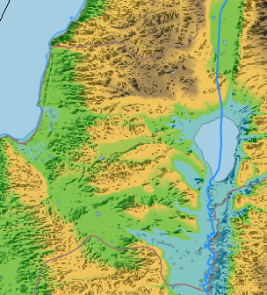

Naim

Endor

Rimmon

Chimki

Legio

Nasara

Hadad-

Rimmon

Jezreel

Megiddo

Mt.

Thabor

Nazareth

Sion

Cesion**6**

Dabareth

Sunem

Thanach

Gur

Sapha

Mt.

Moreh**4**

Japha

Casaloth

Kisloth**7**

Cison

Sichar-

Cedar

Apheca

Hepha

Lower Sephoris

Balbaim

Azanoth

Galaad

Nobah?

Garisima

Upper Sephoris

Mt.

Carmel

Emmaus

Beth-

Lechem?

Cana

Japhia

Ulama

Well of Capharnaum,

Plain of Sharon

Golan

Nobah?

Tarichaea

Debbaseth

Ammonites

Cedar

Edrei

Gadara

Mt.

Gilboa

Abez?

Jezreel Valley**³**

Bashan

Zarthan

Manathea

Selcha

Bosra

Scythopolis**5**

Kamon

Abila

Betharamphtha-Julias

Little Mt.

Hermon

Adam

Ainon

Caesarea

Maritima

Ginnaea**¹**

(En-G)An(n)im**²**

Dothan

Ti

rzah

Abelmahula?

Salem

Pella

Jogbeha

Ephron

Aser-Machmethat

Ataroth?

Meroz

Thebez

Iscariot

Jordan

Jabbok

Gerasa

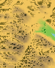

Shechem

Sichar

Mt.

Ebal

Mt. Gerizim

Jacob's Well

Salem

Lebona

Kibzaim?

Joseph's

field

Samaria

Akrabis

Beth Sur

Arga?

Mahanaim?

Thantia

Jabesch-Galaad?

Apollonia

Juttah

Bethaven Des.

Succoth

Thanath-S(h)ilo(h)

Korea

Alexandrinum

Datheman

Dibbon

Gazer?

Joppa

S(h)ilo(h)

Phasael

Aruma

Machmas?

Gophna?

Ramoth-Galaad?

Moses’

grave

Amman/Philadelphia

Eponyms

1.) Ginnim/Jenim

2.) Balbaim/Ibleam

3.) Esdrelon Valley

4.) Mt. Mizar

5.) Bezech

6.) Cedes/Kishion

7.) Chesulloth

8.) Kadesh/Cades

Gilgal

Ataroth

Ophra

Beth El, Luz

Ai

Mt.

Quaran-

tania

Forest of Ephraim

Jericho

Publicans'village

On(o)

Mt. Nebo

Bethoron

Antipatris

Hes(h)ebon

Elealah

Bethjes-

imoth

Emmaus

Emmaus-Nicopolis

Adumim

Gabatha

Bethzur

Bethagla

Bethabara

Betharaba

Bethlehem

Madian?

Ozensara

Ashdod

Ashkelon

**Jerusalem**

Machaerus?

Ephron?

Bethsoron?

Malaga?

Jesus' Temptations site #2

Libna?

Callir-rhoe

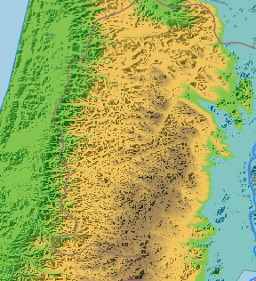

Gia

Ramah/Najoth

Mizpeh

Anathot(h)

**Jeru-**

**salem**

Bethany

Bethphage

Gibea(h)

Geba

Amma

Eleutheropolis

Machaerus?

Livias

Juttah

Grove of Mambre

Hebron

Gaza

“ ‘

Key

* City whose location Emmerich identifies uniquely, or against the common, modern opinion.
* City mentioned by Emmerich.
* Other contemporary city

Hazezon-Thamar

ruins

Bethain

Jachza

Engaddi

Aroer?

(Enz)An(n)im?

Beersheba

Dead Sea

Mesada

Gaza?

(Tha)Mara